11/03/2024

Subashini Mahadevan

DATA TECHNICIAN SKILLS BOOTCAMP – JUST IT

Assignment1- Data Visualisation

Excel &Tableau Assignment

**Contents**

The Wealth of Nations 4

Scenario: 4

**First Task** 5

Policies and Procedures: 5

Policies and procedures in this Assignment: 6

**Second Task** 8

**Excel:** 8

Set a password to Open the Workbook 8

Method1 : 8

Method2: 9

Highlight column C and change the data to display in British Pound symbol 10

Turn the GDP Sheet into a Table: 12

Filter the table to display only the information for 2019 14

Create a chart: 14

Map: 15

Funnel Chart: 16

Bar Chart To Display Top Ranking Countries 17

**Third Task** 19

**Tableau:** 19

**Requirement:** 19

**Initial Analysis:** 19

**Connecting Data:** 19

**Tableau Features Used:** 19

Edit Axis – 19

Sort – 19

Calculation Fields 19

Other Fields – 20

Filter cards - 20

**Dashboard1 – GDP OF Top 20 Countries:** 21

1.Visualization1 - GDP Top 20 (Bar Graph): 21

2.Visualization2 – GDP By Location(Map): 21

3.Visualization3 – Average GDP Over Years(Line Graph): 21

4.Visualization4 - %Contribution Of Each Country in Top20: 21

Dashboard 22

**Dashboard2 Impact Of GDP On Life Expectancy & Smartphone Users:** 22

1.Visualization1 - Life Expectancy Of Top 20 Countries(Tree maps): 22

2.Visualization2 -Life Expectancy Of Top 20s in GDPS (Bubble Chart): 23

3.Visualization3 – Smartphone users Top 20(Line Graph): 23

Dashboard: 23

**Snapshots For Tableau** 24

Import data and set Relationships: 24

Data Cleaning: 25

Check Data Type: 27

Build charts 28

Calculation Field 32

GDP Average Calculation Field 32

Custom number format for percentage 37

Life Expectancy Country Field: 37

Life Expectancy at Birth : 38

Life Expectancy Average Calculated Field: 38

Group Field 39

Minimum value Field: 41

GDP Country Filter card: 41

Calculated Field for Average Of Smartphone Users for entire data: 42

Calculated Field for average of smartphone users with Custom number format: 43

Custom Format for Fields to Display values in Billions 43

Custom Format for Fields to Display values in Millions 43

Number Format (Custom): 44

Filter card for Country Of Life Expectancy: 44

Average Filter Card 46

Country Filter by Condition 46

Edit Axis 47

Edit Alias 48

**Feedback :** 48

# The Wealth of Nations

## Scenario:

Data visualisation has become an essential business capability to help transform information into insights that can drive meaningful business outcomes and improved experiences. Today, most organizations have accumulated a wealth of data from the different corners of their businesses they are then unable to see how this data can help them make better decisions, making actions, and results. You have been asked to Look at the data workbook and familiarize yourself with this data. You have also been asked to create a visual report that will show the data in the form of charts and maps using Tableau to the client’s requirements. You will also need to consider data protection and computer misuse policies.

## **First Task**

### Policies and Procedures:

Establishing policies and procedures for data analysis is crucial for ensuring the accuracy, reliability, and ethical use of data. Here are some general guidelines and considerations for creating such policies:

1. **A Data Handling Policy is a set of rules for employees to follow when working with data.**It is designed to **complement a Data Protection Policy**, which is a security policy created to monitor and manage an organization's data. Both policies fall under the broader discipline of data management, i.e., collection, processing, analysis, storage, and protection.

* Classification system is designed to identify different levels of sensitivity and corresponding levels of risk. For example, publicly available data could be classified as level 1 with a very low level of risk. In contrast, Social Security Numbers and credit card information may be labelled as level 5 and require substantial protections such as multifactor authentication to access.
* Publicly available data could be classified as level 1 with a very low level of risk. In contrast, Social Security Numbers and credit card information may be labelled as level 5 and require substantial protections such as multifactor authentication to access.

Data Protection Policy that covers the following areas:

* + - Safeguarding data
    - obtaining consent from the owner of the data
    - understanding which regulations apply to the organization and data it collects

1. **Data Governance Policy**: Develop a comprehensive data governance policy that outlines the organization's approach to managing and protecting data assets. This policy should cover data quality standards, data access controls, data security measures, and compliance requirements.
2. **Data Quality Standards**: Define standards and guidelines for data quality to ensure that the data used for analysis is accurate, complete, and consistent. This includes establishing protocols for data validation, data cleansing, and error detection.
3. **Data Privacy and Security**: Implement policies and procedures to protect sensitive data and ensure compliance with data privacy regulations such as GDPR, HIPAA, or CCPA. This may involve encrypting data, restricting access to authorized personnel, and implementing data anonymization techniques.
4. **Data Access Controls**: Define roles and responsibilities for accessing and managing data, including who has permission to view, modify, or delete data. Implement access controls and authentication mechanisms to prevent unauthorized access to sensitive data.
5. **Data Retention and Archiving**: Establish guidelines for data retention and archiving to ensure that data is stored securely and retained for the appropriate period. Define procedures for data backup, disaster recovery, and data disposal to minimize the risk of data loss or unauthorized access.
6. **Ethical Use of Data**: Develop guidelines for the ethical use of data, including principles of data integrity, transparency, and accountability. Ensure that data analysis practices adhere to ethical standards and do not result in bias, discrimination, or harm to individuals or communities.
7. **Monitoring and Compliance**: Implement monitoring mechanisms to track compliance with data analysis policies and procedures. Conduct regular audits and assessments to identify and address any compliance gaps or security vulnerabilities.
8. **Documentation and Reporting**: Maintain documentation of data analysis processes, methodologies, and findings. Provide clear and concise reports to stakeholders to communicate the results of data analysis and any associated risks or recommendations.
9. **Continuous Improvement**: Establish a process for continuous improvement to review and update data analysis policies and procedures in response to changes in technology, regulations, or business needs. Solicit feedback from stakeholders and incorporate lessons learned from past experiences.

By implementing robust policies and procedures for data analysis, organizations can ensure the integrity, security, and ethical use of data assets while maximizing the value derived from data-driven insights.

**Policies and procedures in this Assignment:**

Data Handling:

Made sure the data was used as it is except for Data cleaning while visualizing, and filtered the data to avoid null values. And made a copy of the data initially given so that can have a back up if initial data if something gets deleted or changed accidentally. In the Analysis process took a back up of the data in some places to have the changes made in data so that I can access whenever I wanted.

Data Security and Protection:

Protected the workbook with applied passwords for modifying the data. In this way data can be protected by providing the access control to the necessary people who really want the access to data . Unless and until it is required modification rights are not given for the sensitive data. And we can make sure that read only rights are enabled for the people. Also Copy of the original data can be given to work with. In this assignment Access control is managed by protecting the workbook this can be done by protecting a workbook, protecting certain sheets alone in a book and allowing to change other sheets. Also Certain range of cells in a Excel sheet can be protected and restricting the modification to those cells by password protection. In Tableau dashboards are created and store in Tableau desktop (personal) environment and it is published to public only when it required and access control for the Published dashboards can be given to selected people and links can be shared to the required people,

Ethical use Of data:

Do not misuse the data and it’s the responsibility of the person to safeguard the sensitive data like ethnicity, medical history of patients and personal details of other. Data should not be placed in a public workspace or social networking this is ethical use of data.

Documentation and Reporting:

### Laws Of Data Protection

These are laws designed to protect users and their data from attack   
and misuse:

Computer Misuse Act 1990

Police and Justice Act 2006 (Computer Misuse)

Copyright, Designs and Patents Act 1988

The Copyright (Computer Programs)   
Regulations 1992

The Health and Safety (Display Screen   
Equipment) Regulations 1992

Data Protection Act 2018

Consumer Rights Act 2015

# **Second Task**

## **Excel:**

### Set a password to Open the Workbook

### Method1 :

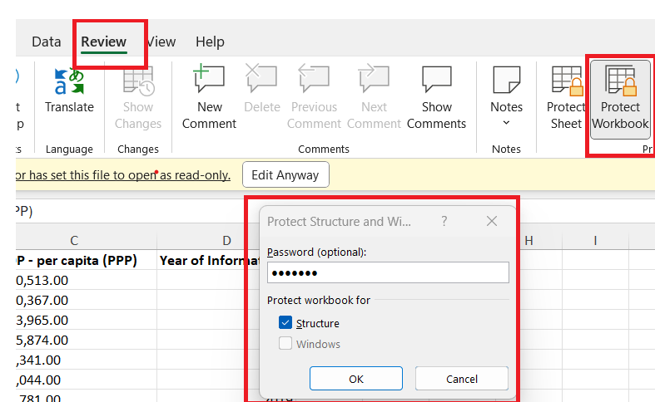

Now when you close the file and open to see you cannot delete or move the sheets in excel without password.

### Method2:

Click File ->Save As -> then Select General options

Password is **OpenMe!**

Now when you close the file and open to see you cannot delete or move the sheets in excel without password.

### Highlight column C and change the data to display in British Pound symbol

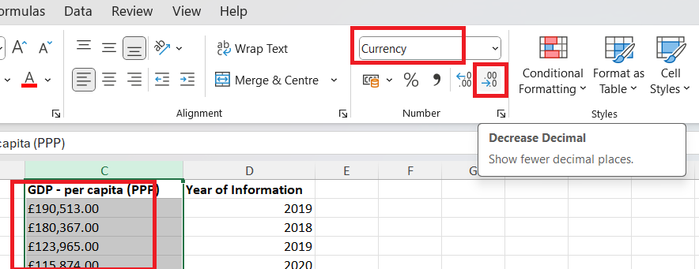

Now the currency appears in correct format like the £190,513

### Turn the GDP Sheet into a Table:

### **Filter the table to display only the information for 2019**

### **Create a chart:**

Create a chart that will only display the following data ‘Rank, Country and GDP - per capita (PPP). The chart can be anything as long as it is suitable.

Select the Column names Rank, Country and GDP by clicking Ctrl and select Column A,B &C. Now Click the Insert -> Recommended Charts and select BAR Chart.

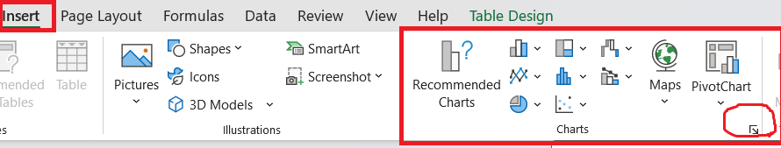

### **Map:**

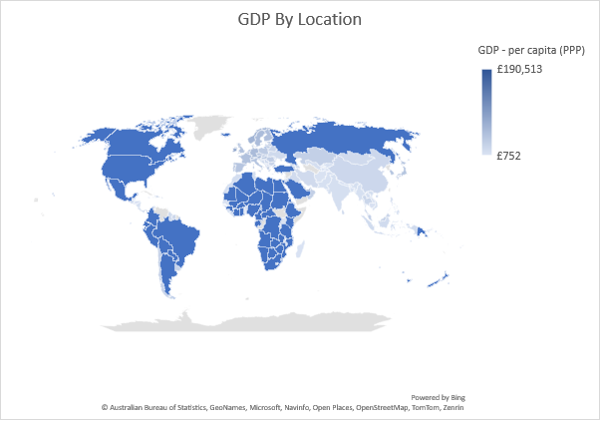

### **Funnel Chart:**

### 

Create a sort for the top 20 highest ranking counties

### **Bar Chart To Display Top Ranking Countries**

Top 20 Ranked Countries:

This visualization displays Top 20 GDP Ranked countries for the year 2019.

## **Excel Macros**

Task Description:

Three Macro buttons are created for copy, save and print.

### **VBA Code for Copy and save buttons**

**Description :**

VBA code for copy macros is written in such a way that it copies the current excel sheets range A1:D21 and paste them in a word document in the path

C:\Users\subab\OneDrive\justIT\Assignments\Assignment 1\Excel Gross domestic product report 1.docx

Word document holds the title and table from excel sheet .

**Sub copy_2()**

'

' copy_2 Macro

'

Dim wb As Excel.Workbook

Dim ws As Excel.Worksheet

Dim wdapp As Object

Dim wddoc As Object

Set wb = ActiveWorkbook

Set ws = wb.Sheets("GDP")

If ws Is Nothing Then

MsgBox "Worksheet 'GDP' not found in the workbook."

Exit Sub

End If

ws.Range("A1:D21").Copy

End Sub

**Sub Macro3()**

Dim wdapp As Object

Dim wddoc As Object

On Error Resume Next

Set wdapp = GetObject(, "Word.Application")

If Err.Number <> 0 Then

MsgBox "Error: " & Err.Description

' Handle the error as needed

End If

On Error GoTo 0

wdapp.Visible = True

Set wddoc = wdapp.Documents.Open("C:\Users\subab\OneDrive\justIT\Assignments\Assignment 1\Excel Gross domestic product report 1.docx", ReadOnly:=False)

wdapp.Selection.TypeText "GDP (Gross domestic product)" & vbCrLf & vbCrLf ' Adjust the title as needed

'wddoc.Range.PasteExcelTable LinkedToExcel:=False, WordFormatting:=False, RTF:=False

wdapp.Selection.PasteSpecial DataType:=wdPasteText

wddoc.Save

wddoc.Close

' Clean up

Set wdapp = Nothing

Set wddoc = Nothing

Set ws = Nothing

Set wb = Nothing

End Sub

### **Macros VBA code for print code**

Sub print2()

' print2 Macro

ActiveWindow.SelectedSheets.PrintOut Copies:=1, Collate:=True, _

IgnorePrintAreas:=False

End Sub

# **Third Task**

## **Tableau:**

## **Requirement:**

Data Visualization in Tableau. Create a minimum of 4 visualizations. Build a Dashboard for Wealth Of Nations data.

## **Initial Analysis:**

**Data Available:**

Wealth Of Nations has three sheets with information related to GDP, Life Expectancy and Smartphone users for each country. Though Country is the common field associated in all the sheets but they don’t match exactly, so they are missing in other sheets. Keeping in mind that this data is for Wealth Of Nations, analysis is done on the GDP data for countries and the impact of GDP on countries in a positive way. Hence created 2 Dashboards – one for GDP of countries and the other one is for impact of GDP on Life Expectancy and Smartphone users.

**Dashboard Details:**

First Dashboard mainly focuses on GDP Of Top 20 Ranked nations and Second Dashboard is for the impact Of GDP on Life Expectancy and SmartPhoneusers. Used **Color Blind10** from the color palette in all the visualizations.

## **Connecting Data:**

GDP data is available for the years – 2003 -2020. Whereas Life Expectancy and Smartphone users data are available for the year 2020. So we can connect these sheets only using the common field “country”.

After connecting the Data, checked for the data type and found only year was the wrong type int, else all other fields were fine.

## **Tableau Features Used:**

In this tableau Assignment I have tried the following features in the Tableau to get the output in the desirable format

### Edit Axis –

* Change names
* Change Range Of Axis to display the visualization in desirable format – Range->Custom->Fixed start = 80 and Fixed End = 85.5 For Life Expectancy of Top 20 countries

### Sort –

Right click axis ->Sort ->By Field -> Life Expectancy at Birth -> By Descending ->

Right click axis ->Sort ->By Field -> Rank (GDP)-> By Descending ->

### Calculation Fields

Average –

1. AVG GDP – Calculated the average of GDP data(filtered to Top 20 ranked countries) in the visualization
2. AVG Life Exp - Calculated the average of Life Expectancy data(filtered to Top 20 ranked countries) in the visualization
3. AVG Smartphone Users – - Calculated the average of Smartphone users data(filtered to Top 20 ranked countries) in the visualization
4. AVG GDP Total – Calculated the Fixed average of GDP per capita(PPP) across all records in dataset .

Percentage -

1. GDP Percentage Total - Percentage contribution of each country to the total.
2. GDP Percentage – Percentage contribution of each country to the top 20 values.

Groups –

1. Life Expectancy Top 20 Group - For grouping the countries that share the same Life expectancy ex ) South Korea, Iceland Ireland

### Other Fields –

* TotalGDP – Calculated the sum of Total GDPvalue available in the visualization(after using filter for Top 20 countries)
* TotalGDP FIXED - Calculated the sum of TotalGDP value of each record in the dataset.
* Life expectancy at birth Min – It calculates the minimum values of the Life Expectancy in the visualization, used it mainly for displaying the Life expectancy value for grouped countries in the bar hart and Tree maps because by default it displayed the sum of Life Expectancy value of the grouped countries.

This is optional we can also do this by selecting right click Field -> Measure->Minimum

* Smartphone Users in B – To display the smartphone users value from the dataset field (Smartphone users) in Billions so that we can display in the Visualization in billions. Used it in the place where it needed it to be displayed in Billions to compare. Used a Custom number format for this by right click the field in the data pane right click->Default properties ->Number Format->Custom (#,##0.0,,"B")
* Smartphone Users in M - To display the smartphone users value from the dataset field (Smartphone users) in Millions. Used in a Line Chart to show the Smartphoneusers for Top 20 GDP Ranked Countries . Used a custom number format for this. Used a Custom number format by right click Field(in data pane) ->Default Properties ->Number Format -> Number(Custom) and selected the display units as Millions and Decimal places as 2.

### Filter cards -

Condition –

* Life Expectancy Country Filter - By Field- >Life Expectancy at Birth -> Sum -> ‘ > 82.1’ – because Top 20 countries fall under 82.1
* Country Filter for GDP – By Field - > GDP Per capita ->Sum - > ‘> 57,000’

Top –

* Country Filter – By Filed -> Top -> 20 - >GDP Per Capita ->sum
* Country Filter for GDP in map - Top ->By Field ->Rank (GDP) - >20 or parameter1 ->Sum

Range -

* GDP Fiter card – Range Of values ->57,000 -3,52,066 – Display the values in Top 20 ranked countries
* AVG GDP – For average filter card in GDP Line chart

## **Dashboard1 – GDP OF Top 20 Countries:**

Created 4 Visualizations

### 1.Visualization1 - GDP Top 20 (Bar Graph):

Visualization of Top 20 Ranked Countries Of GDPS with Country, GDP Per Capita, AVG GDP Total – average Of Entire dataset, Rank(GDP) in detail card.

### 2.Visualization2 – GDP By Location(Map):

Country, GDP Per capita and Rank(GDP) in Detail card.

### 3.Visualization3 – Average GDP Over Years(Line Graph):

Year Of Information, GDP Per Capita and AVG GDP in the detail card.

### 4.Visualization4 - %Contribution Of Each Country in Top20:

Country Of GDP, GDP Per Capita and GDP Percentage(Percentage in Top 20) added to the details card.

### **Dashboard**

Link to Dashboard :

<https://public.tableau.com/views/Assignment_17096639275850/Dashboard1?:language=en-GB&publish=yes&:sid=&:display_count=n&:origin=viz_share_link>

## **Dashboard2 Impact Of GDP On Life Expectancy & Smartphone Users:**

### 1.Visualization1 - Life Expectancy Of Top 20 Countries(Tree maps):

Visualization of Top 20 Ranked Countries Of Life Expectancy with Country Of Life Expectancy, AVG Life Expectancy, Minimum GDP Per capita, Min Rank Of Life Expectancy, AVG GDP Total, Life Expectancy at Birth added to the detail card.

### 2.Visualization2 -Life Expectancy Of Top 20s in GDPS (Bubble Chart):

Country Of GDP , AVG Life Exp, GDP Per Capita, GDP Percentage Total, Life Expectancy at Birth and Rank(GDP) in the details card.

### 3.Visualization3 – Smartphone users Top 20(Line Graph):

Country Of Smartphones,Average Smartphone users, AVG Life Exp, GDP Per Capita, AVG GDP Total, Life Expectancy at Birth , Rank Of GDP, Smartphone users in Millions added to the detail card.

### **Dashboard:**

**Link to the Dashboard:**

[**https://public.tableau.com/views/Assignment_17096639275850/Dashboard2?:language=en-GB&publish=yes&:sid=&:display_count=n&:origin=viz_share_link**](https://public.tableau.com/views/Assignment_17096639275850/Dashboard2?:language=en-GB&publish=yes&:sid=&:display_count=n&:origin=viz_share_link)

## **Snapshots For Tableau**

### **Import data and set Relationships:**

Imported the Excel sheet in Tableau and formed relationships between the Tables . Please refer the snapshots:

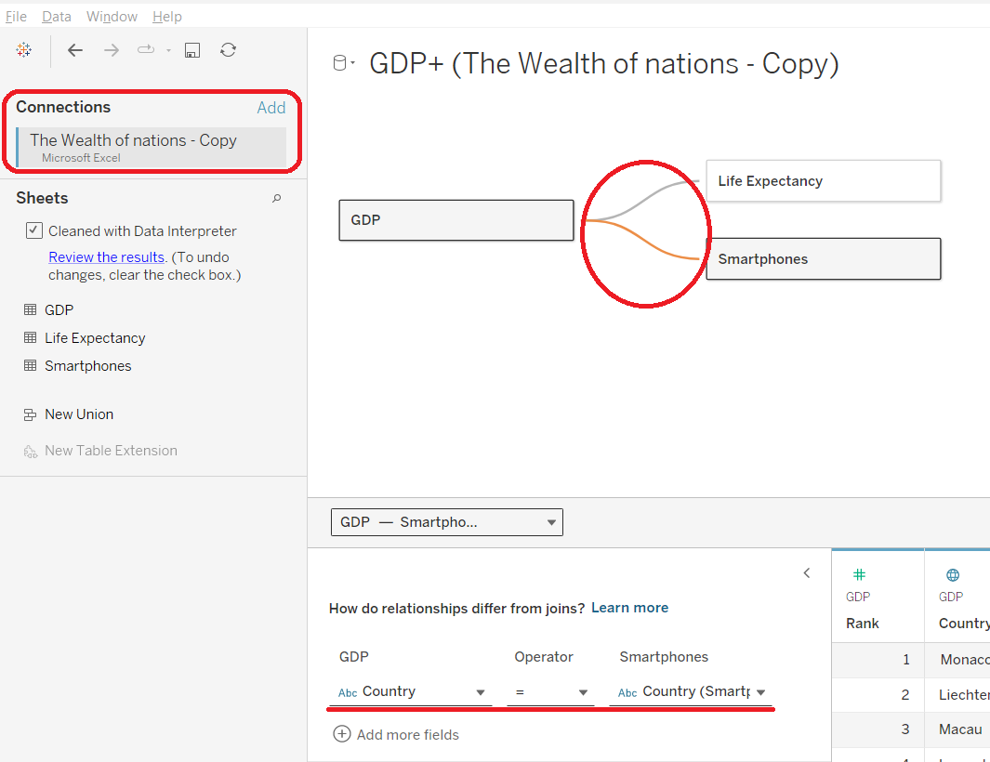

### **Data Cleaning:**

And then it automatically opens an excel sheet names Marked.WealthOfnations which shows how the data is interpreted.

### **Check Data Type:**

Checked data type for all the fields and found only date field does not match.

### **Build charts**

You are now ready to create charts. Please make sure to create at least 4 visuals. There is no upper limit.

1. MAPS

Creating a set of top 20 countries by mentioning the condition in condition tab

We can specify the condition either by selecting by formula or by selecting by field ->select Rank->Maximum-> and specify <=20

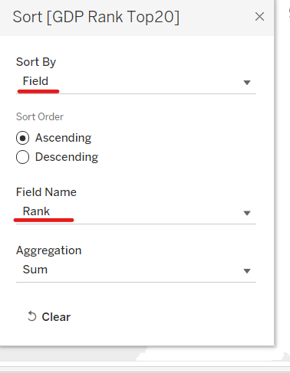

MAP FOR Life expectancy :

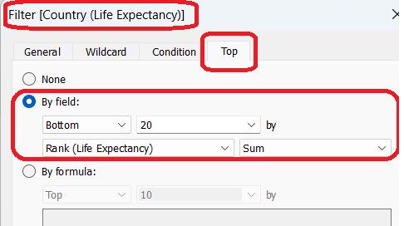

**Smartphone users Visualizations:**

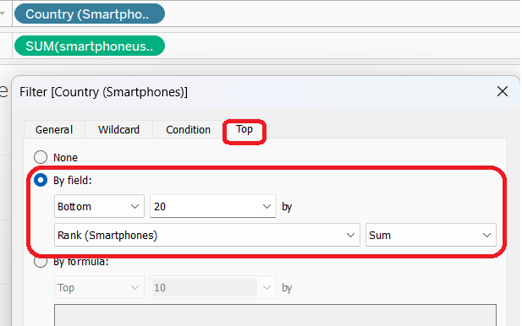

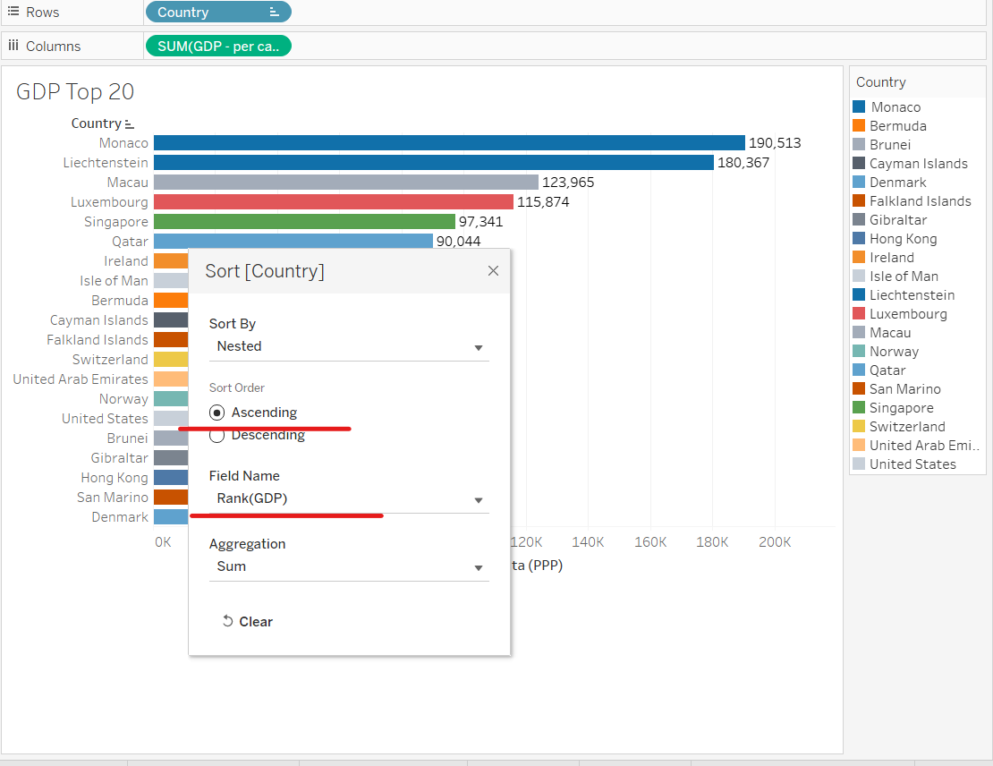

### **Calculation Field**

Create Calculated field for smartphone user to convert the value to billions. And format the axis and calculated field to display the value in billions.

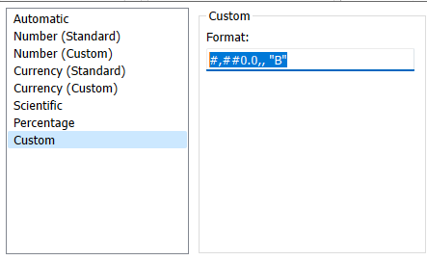

### GDP Average Calculation Field

### **Custom number format for percentage**

### **Life Expectancy Country Field:**

### **Life Expectancy at Birth :**

### **Life Expectancy Average Calculated Field:**

GDP Average Calculation Field for displaying the Fixed Total average for al the countries:

### **Group Field**

Creating a Group Field for grouping Countries that share the same Life expectancy value in top countries.

Created 2 Groups For Countries (South Korea, Israel, Ireland) and other one is for (Netherland, New Zealand, Luxembourg and Ireland)

### **Minimum value Field:**

Life Expectancy at Birth Value displayed in minimum by Duplicating a Life Expectanyc at Birth Field and Creating a calculation for minimum value

### **GDP Country Filter card:**

Filtered values for top 20 GDP countries by condition

### **Calculated Field for Average Of Smartphone Users for entire data:**

### **Calculated Field for average of smartphone users with Custom number format:**

### **Custom Format for Fields to Display values in Billions**

### **Custom Format for Fields to Display values in Millions**

### **Number Format (Custom):**

### **Filter card for Country Of Life Expectancy:**

### **Average Filter Card**

### **Country Filter by Condition**

### **Edit Axis**

### **Edit Alias**

## **Bubble chart:**

Bubble chart and Tree maps are same.

### **Normal bubble chart: picture1:**

You have to click the ctrl + click Country and GDP Per Capita and then select Bubble chart.

Now add the country to colour card and see a chart like the one in picture1 .

### **Packed Bubble chart: picture2**

Now duplicate he GDP per capita Field and right click->create ->group. Now group the GDP values in groups like High, Middle and Low.

Low values ranges from 0 – 10000

Middle – 10000- 50000

High – 50000 to 200000

Drag the Group GDP field to the colour card.

You can see a Packed Bubble chart like the pictur2 below

Link to Published Worksheet - [Assignment | Tableau Public](https://public.tableau.com/app/profile/subashini.mahadevan/viz/Assignment_17096639275850/PackedBubblemap?publish=yes)

## **Pie Chart**

### **Normal Pie chart:**

Ctrl + click Country GDP1 Field (which is the same country values as in Country Field) and GDP Per capita Field to the size card. Now drag the GDP Percentage field to the Label .

### **Multiple Pie chart:**

Now I change the Normal Pie chart in the above visualization to Multiple Pie chart I am going to use the GDP Per capita Grouped field instead of GDP Per Capita field.

This Grouped field has 3 groups as Low, Middle and High.

Low ranges from 0 – 10000

Middle - 10000 – 50000

High – 50000 – 200000

Sorry I am trying for this wealth of nations data But I can post the snapshot for the sales data

## **Word Map :**

Link to published Visualization:

[Assignment | Tableau Public](https://public.tableau.com/app/profile/subashini.mahadevan/viz/Assignment_17096639275850/WordMap?publish=yes)

I have created the Word map by just changing the shapes to Text in a Packed Bubble map I created earlier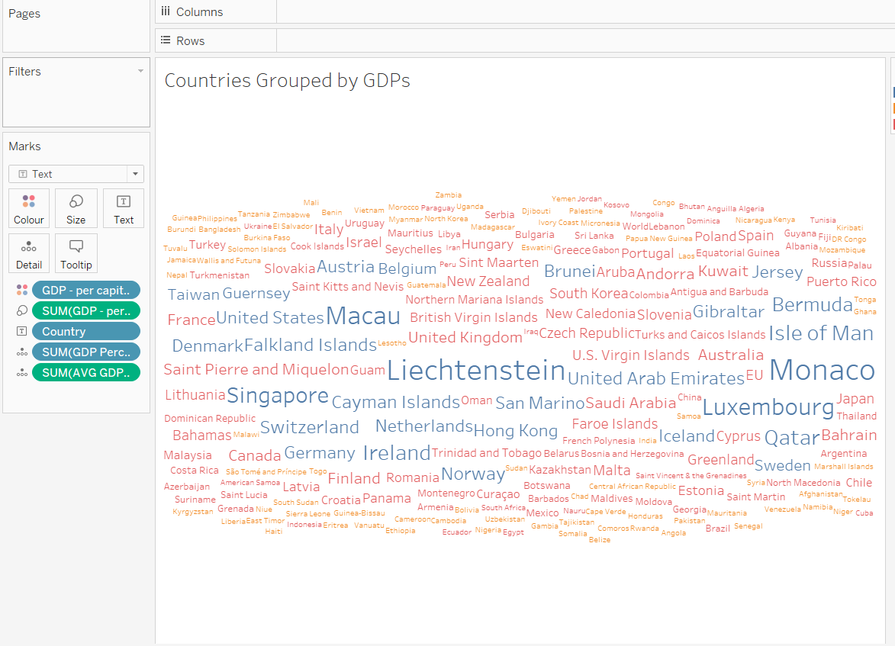

# **Feedback :**

|  |  |
| --- | --- |
| **Topic** | **Feedback** |
| Policies and Procedures: |  |
|  |  |
| Excel: |  |
|  |  |
| Map: |  |
|  |  |
| Funnel Chart: |  |
|  |  |
| Bar Chart To Display Top Ranking Countries |  |
|  |  |
|  |  |
| Tableau: |  |
|  |  |
|  |  |
|  |  |
| Dashboard1 – GDP OF Top 20 Countries: |  |
|  |  |
|  |  |
| Dashboard2 Impact Of GDP On Life Expectancy & Smartphone Users: |  |
|  |  |
|  |  |
|  |  |
| Overall Feedback |  |
|  |  |
|  |  |
|  |  |
|  |  |